**Note there is already 1 example training model that was already done. In this case it was vgg_unet, so if you don’t want to train and just see how it works:**

1. Unzip and follow step 1-4 from **Training and Validation of Deep Encoder-Decoder Networks Stage 2 on Rebar Dataset**

2. The prediction model is in **checkpoints/** folder

3. Go into **prediction** folder which will give you the predict from model for images in **example_dataset/images_prepped_test**

4. Run the code line given below in the command prompt to get metric like precision, iou score, etc

**python3 -m keras_segmentation evaluate_model --checkpoints_path="checkpoints/checkpoints" --images_path="example_dataset/images_prepped_test" --segs_path="example_dataset/annotations_prepped_test"**

*note: there might be some warnings so you might have to scroll around to find the print statement in terminal.*

5. To train, go to next section will show you stage 2 & 1.

**Training and Validation of Deep Encoder-Decoder Networks** **Stage 2 on Rebar Dataset**

1. Download the code ZIP file.

2. Unzip the folder

3. Install gpu for Tensorflow (recommended version: 2.4.1) <https://www.tensorflow.org/install/gpu>

4. Resolve the following dependencies:

* Keras (recommended version: 2.4.3)
  + Use the command “**pip3 install keras**“
* OpenCV for Python
* [imgaug](https://www.tensorflow.org/install/gpu)
* tqdm

5. Run the code for training the SegNet or other frameworks using the code line given below:

**python3 -m keras_segmentation train --checkpoints_path="results/xception_segnet/" --train_images="dataset/train_img" --train_annotations="dataset/train_lab" --val_images="dataset/test_img" --val_annotations="dataset/test_lab" --n_classes=2 --input_height=512 --input_width=512 --model_name="xception_segnet" --epoch=150 --batch_size=8 --do_augment=False**

where **segnet** is, switch out different type of encoder + base model combinations like ‘xception_segnet’, ‘vgg_segnet’, etc. Refer to paper for all different types for stage 2. **checkpoints** is where the model will go. If you just have checkpoints, then all model will be in **Segmentation + segnet/** folder. If you want your model to go to a different folder like mine where I have it in **checkpoints/,** then first create a folder name **<folder name>**, then in place of **checkpoints**, put in **<folder name>/checkpoints.**

For input height and width, please check the base model requirement by opening **keras_segmentation/models/<base model name>.py** and input the right width and height, you will get errors. Below is the base model and encoder names:

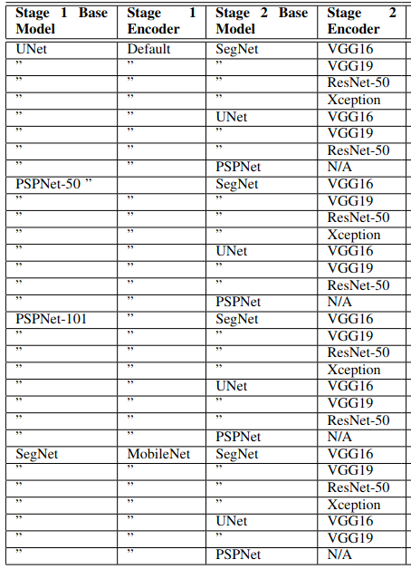6. Run the code line given below in the command prompt to validate the trained Deep Encoder Decoder system:

**python3 -m keras_segmentation predict --checkpoints_path="checkpoints" --input_path="example_dataset/images_prepped_test" --output_path="prediction"**

For **checkpoints**, if in **step 5** you choose to put your model in **<folder name>/checkpoints**, then you will have to put **<folder name>/checkpoints** in place of **checkpoints**

7. Run the code line given below in the command prompt to get metric like precision, iou score, etc

**python3 -m keras_segmentation evaluate_model --checkpoints_path="result/crack/checkpoints/xception_segnet/xception_segnet" --images_path="dataset/image_crack" --segs_path="dataset/mask_crack"**

*note: there might be some warnings so you might have to scroll around to find the print statement in terminal.*

For **checkpoints**, if in **step 5** you choose to put your model in **<folder name>/checkpoints**, then you will have to put **<folder name>/checkpoints** in place of **checkpoints**

**Training and Validation of Deep Encoder-Decoder Networks** **Stage 1 on Rebar Dataset**

1. Follow step 1-4 in **Training and Validation of Deep Encoder-Decoder Networks** **Stage 2 on Rebar Dataset**

2. Run the code for training the SegNet or other frameworks using the code line given below:

**python3 -m keras_segmentation train --checkpoints_path="checkpoints" --train_images="example_dataset/Img" --train_annotations="example_dataset/Img_Seg" --val_images="example_dataset/Img_Test" --val_annotations="example_dataset/Img_Seg_Test" --n_classes=2 --input_height=764 --input_width=764 --model_name="mobilenet_segnet" --epoch=100 –batch_size=8**

where **mobilenet_segnet** is, switch out different type of encoder + base model combinations like ‘unet’, etc. Refer to paper for all different types for stage 1

* The folder **Rebar First Stage** should give all predictions for all types of combination models

**Mixing Data**

I am not sure how Habib mixed his data so I did it randomly.

First number of image file name is bridge number.

You can mix and match the validation set and training set however you want.

**python3 -m keras_segmentation best_model_test --checkpoints_path="result/checkpoints/xception_psp/checkpoints" --images_path="dataset/image_crack" --segs_path="dataset/mask_crack"**

python3 -m keras_segmentation train_continue --model_path="results/xception_sp_pw_dw/checkpoint-3-0.8662-.hdf5" --checkpoints_path="results/xception_sp_pw_dw/" --train_images="dataset/_train_img" --train_annotations="dataset/_train_lab" --val_images="dataset/test_img" --val_annotations="dataset/test_lab" --n_classes=2 --input_height=512 --input_width=512 --model_name="xception_sp_pw_dw" --epoch=400 --batch_size=4